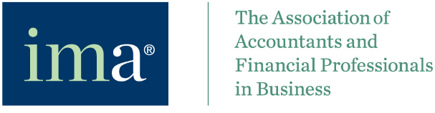

Assumption of Risk and Waiver of Liability Relating to COVID-19 and its Variants

The novel coronavirus (known as “COVID-19”) has been declared a worldwide pandemic by the World Health Organization (WHO). COVID-19, and its variants, are extremely contagious and is known to spread mainly from person-to-person contact. As a result, federal, state, and local governments and their respective health agencies recommend the full use of available vaccinations, social distancing, use of masks, and have, in some situations, place restrictions on the gathering of groups of people.

The Institute of Management Accountants, Inc. (“IMA”) has adopted certain protocol and put in place preventative measures to reduce the spread of COVID-19; however, IMA cannot guarantee that
you will not become infected with COVID-19. Further, attending any program may increase your risk of
contracting COVID-19, and may increase the risk of transmitting COVID-19 to others.

I, ___________________________________(“Participant”) acknowledge the highly contagious nature of COVID-19 and its variants, and voluntarily assume the risk that I, or members of my group or organization, may be exposed to or infected by COVID-19 and its variants by participating in any way in any event, program, activity, reservation or rental taking place at this IMA Event, and that such exposure or infection may result in personal injury, illness, permanent disability, and death. I understand that the risk of becoming exposed to or infected by COVID-19 and its variants at this IMA Event may result from the actions, omissions, or negligence of myself and others, including, but not limited to, IMA employees, volunteers, and other participants and their families.

I __________________________ (am or am not) fully vaccinated against COVID-19 as defined by local health regulations through an approved vaccine along with the lapse of the approved time period.

I voluntarily agree to assume all of the foregoing risks and accept sole responsibility for any injury to myself or members of my group or organization, including, but not limited to, personal injury, disability,
death, illness, damage, loss, claim, liability, or expense, of any kind, that they or I may experience or
incur in connection with participation in this IMA Event. I hereby fully release, covenant not to sue, discharge, and hold harmless IMA, its affiliates, subsidiaries, employees, directors, officers, agents, representatives, successors and assigns, of and from any claims related to COVID-19 and its variants, including all liabilities, claims, actions, damages, costs or expenses of any kind arising out of or relating thereto.

I understand and agree that this release includes any claims based on the actions, omissions, or negligence of IMA, its affiliates, subsidiaries, employees, directors, officers, agents, and representatives, whether a COVID-19 infection occurs before, during, or after participation in this IMA Event.

Participant Signature:

_______________________________
Name:
Date and Name of Event:

